Infineon Controller Technical
. The purpose here is to assist user’s understanding of the features available on the Chinese-made Infineon digital controller.
The Infineon Micro Control Unit (MCU) is the heart of the controller printed circuit board (pcb). The MCU currently in use by the Chinese pcb vendor is the XC846 chip. The pcb’s come in 6, 9, 12, and 18 mosfet versions. This thread is particular to the 12-mosfet pcb . The XC846 MCU and the PWM programming has proven sufficient to drive virtually any motor (including geared motors like the PUMA and BMC) commonly used in electric scooters and e bikes.

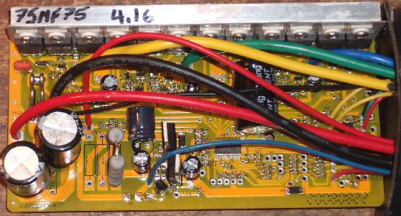
· R12
The Low Voltage Cut-off (LVC) circuit consists of tiny surface mount transistors and one capacitor.
This circuit connects to an MCU pin-out so the MCU can detect the battery voltage.
The R12 resistor is about 1.2 kohm and connects from the MCU pin-out to ground.
R12 can be disabled and replaced with a potentiometer to allow any LVC value.
It is critical, however, that the LVC protects the controller from a low voltage condition.
If the voltage to the mosfet drivers and MCU is not steady the controller will be damaged.
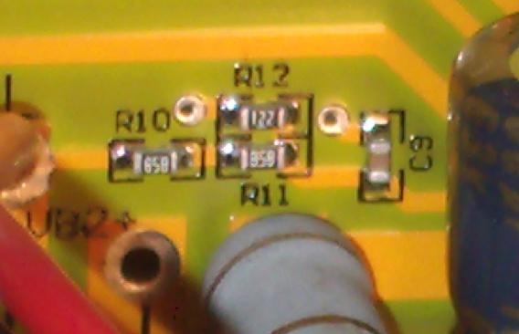
· R44
The R44 circuit connects to the high side of the shunt.
This circuit connects to an MCU pin-out so the MCU can detect the shunt current.
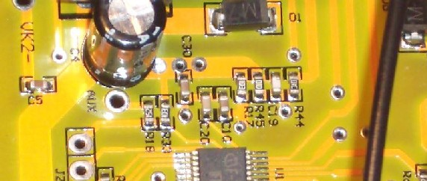
· R01(A,B)
The R01 (A & B) are slots for the power resistors. The selection of these resistors is critical.
They drop the voltage down from the battery voltage to a safe value for the LM317 voltage regulator.
During controller operation, the current thru these resistors is 65 ma (0.065 amps).
Each 100 ohm of resistor value will drop the battery voltage by 6.5 volts.
The choice of resistors is selected by the choice of LVC to prevent controller damage.
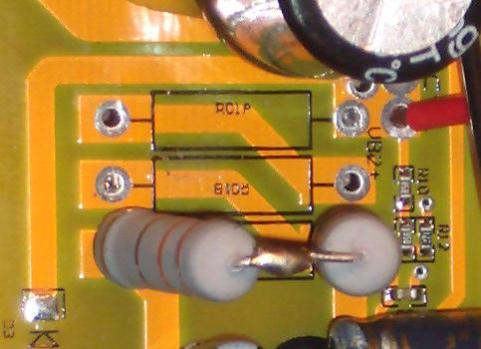
R01AB.jpg (28.6 KB) Viewed 2658 times
· R6
The R6 resistor is a bridge (shunt) across the LM317 V(in) and V(out).
It is provided to cap the voltage drop across the LM317 to no more than 40V.
The choice of this resistor is critical because it provides the voltage "window" of the battery.
If R6 is too small the voltage window will be too small. If R6 is too large the LM317 can be damaged.
· LM317
The LM317 on the pcb is configured as a voltage regulator with V(out) = 12 volts.
Small capacitors near the LM317 reduce voltage spikes in the 12 volt output.
This feeds the 12 volt bus on the pcb. The 12 volt bus powers that mosfet drivers.
According to specification the voltage drop across a LM317 should not exceed 40 volts.
The controller LVC should never be set so low that the 12V bus drops below 12V.
It should be noted, however, that the R6 resistor “relieves” the heat load from the LM317.
If R6 is removed, all 65 milliamps of current will flow thru the LM317.
If the voltage drop across the LM317 is 15 volts then it will generate 1 watt of heat.
If the voltage drop across the LM317 is 30 volts then it will generate 2 watts of heat.
This heat will cause the LM317 to shut down since it has internal thermal protection.
There is no heat sink on the LM317.
But when R6 is installed, it will draw some of the 65 milliamps of current away from the LM317.
Using R6=660 ohm, a 6.6 V voltage drop across R6 will pass 10 milliamps of current.
The LM317 is now only passing 55 ma.
A 13.2 V voltage drop across R6 will pass 20 milliamps of current. LM317 now passing 45 ma.
A 19.8 V voltage drop across R6 will pass 30 milliamps of current. LM317 now passing 35 ma.
A at 40 V voltage drop, R6 will pass all 65 milliamps of current. LM317 is now passing zero current.
But a high voltage drop across R6 will also cause the 12V bus to rise above 12 volts.
The 12V bus can climb as high as 15V or even 16V.
The 5V bus can climb as high 6V.
· 7805
The 7805 is a fixed 5 volt regulator and feeds the 5 volt bus on the pcb.
The 5 volt bus feeds the MCU and the throttle and motor hall sensors.
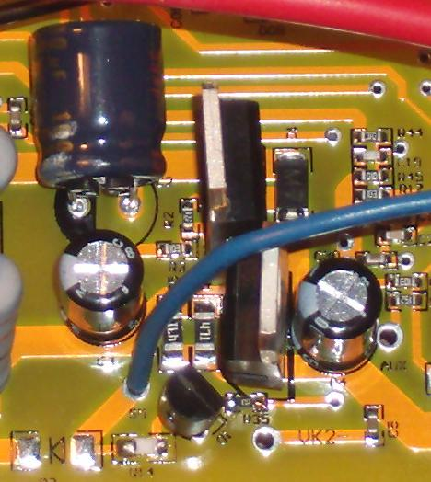

· Shunts
The latest Infineon pcb is fitted with a consistent shunt.
The standardized shunt value is approximately 3.8 mOHM.
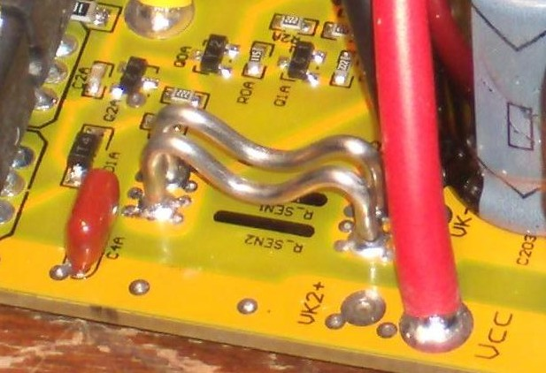
· RECOMMENDATIONS
I recommend the following resistor settings for the Infineon controller.
These values will ensure safe controller operation for the voltage range indicated.
R6 = 2 x 330 ohm (2W) = 660 ohm (4W) on all controllers.
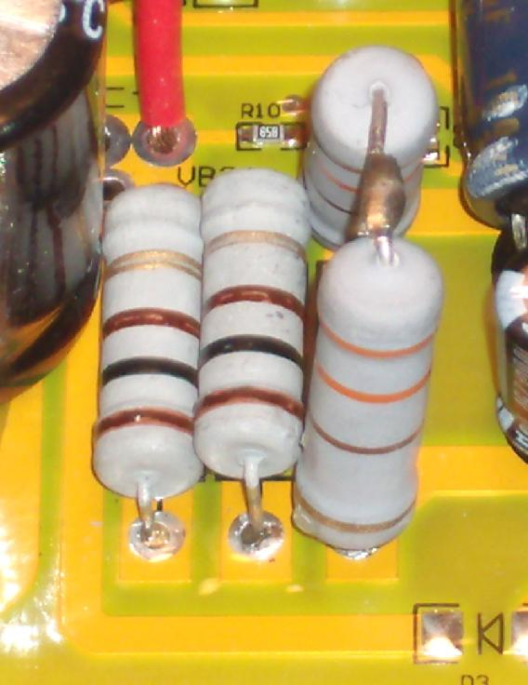
OR ...
R6 = 1 x 680 ohm (3W) on all controllers.
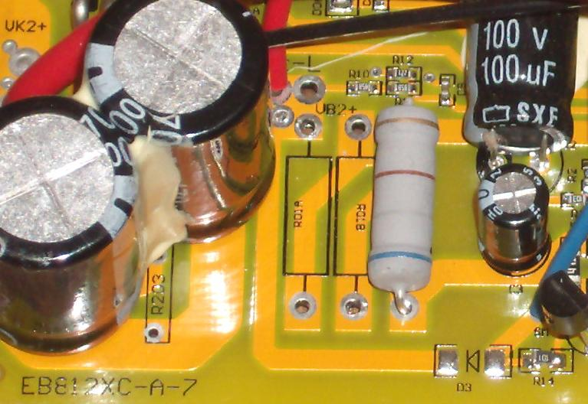
Nominal Battery Voltage = 24V
LVC = 20 volts
R01(A,B) = bypass
Maximum Safe Operating Voltage = 50 volts
Nominal Battery Voltage = 36V
LVC = 30 volts
R01A = 100 ohm (2W)
R01B = 100 ohm (2W)
Maximum Safe Operating Voltage = 60 volts
Nominal Battery Voltage = 48V
LVC = 40 volts
R01A = 180 ohm (2W)
R01B = 200 ohm (2W)
Maximum Safe Operating Voltage = 70 volts
Nominal Battery Voltage = 60V
LVC = 50 volts
R01A = 200 ohm (2W)
R01B = 330 ohm (2W)
Maximum Safe Operating Voltage = 80 volts
Nominal Battery Voltage = 72V
LVC = 60 volts
R01A = 330 ohm (2W)
R01B = 330 ohm (2W)
Maximum Safe Operating Voltage = 90 volts
.
btw ... I started adding a thin sheet of PVC plastic between the bottom of the pcb and the aluminum case.
Just to make sure the Mod circuits don't touch the bottom of the case.

Infineon Controller Software Settings
The Infineon controller is very versatile and can be used in a variety of lightweight EVs.
It has several programmable features that extend beyond the needs of most e bikers but may come in handy to folks in certain e bike applications.
The flash program software (right click "Save Target As...") ... http://98.131.176.65/endless-sphere/Par ... signer.exe
And a demonstration file (right click "Save Target As...") ... http://98.131.176.65/endless-sphere/Demo.asv
You may need to add some COM PORT files for your particular PC OS (Richtx32.ocx & MSCOMM32.OCX).
These are here also (right click "Save Target As...") http://98.131.176.65/endless-sphere/Richtx32.ocx & http://98.131.176.65/endless-sphere/MSCOMM32.OCX
These need to be copied into the C:\WINDOWS\system32 directory for the Parameter Designer.exe to work properly.
Note: hit transmit on pc program then momentary on switch from usb ttl connector to transfer data from computer to controller chip.

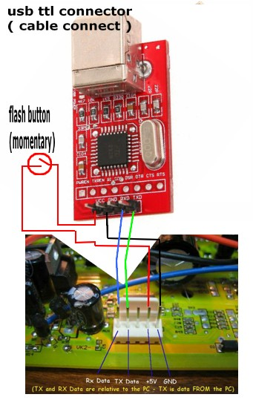
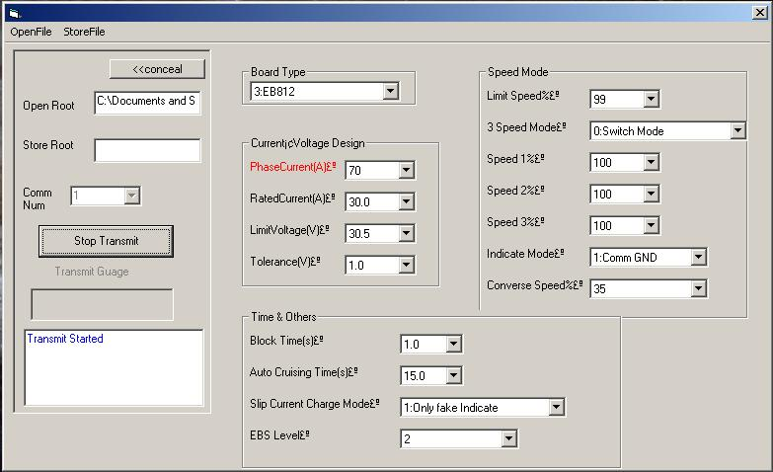
· Speed Controls and Reverse
The Infineon controller allows for a variety of Speed Settings.
Percentage values for the Speed Settings are chosen by pull down menus in the “Parameter Designer” software.
The “Speed 1, 2 and 3” settings allow for values from 30% to 120% of full speed.
The “Limit Speed” setting allows for values from 50% to 99% of full speed.
The “Converse Speed” (reverse) setting allows for values from 15% to 70% of full speed.
PLEASE NOTE: The throttle ALWAYS controls the motor speed.
The various speed settings simply set the MAXIMUM for wide open throttle (WOT).
There are also two Speed Modes available …
0: SWITCH MODE
1: CYCLE MODE
These settings are activated by jumping specific contact points of the pcb to ground.
The contact points are “SL”, “X1”, “X2”, and “DX3”.
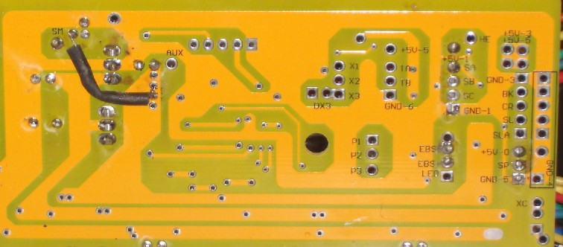
0: SWITCH MODE …
When “0: SWITCH MODE” is chosen as the mode of operation, the Infineon controller will default to the speed value selected for “Speed 2%”. This is the value the controller “sees” when none of contact points (SL, X1, X2, or DX3) are activated or used. This value is typically set to 100%. It is believed that values over 100% may increase speed by using a “phase advance” feature but values over 100% may not function well with higher rotor rpm (geared) motors. Of course reverse will not work with geared motors with an internal freewheel (like the Bafang PMGR).
SL …
(0: Switch Mode) When the “SL” contact point is “jumped” to ground (when SL is connected to ground) then the programmed value for “Limit Speed%” overrides the default “Speed 2%” setting. If the SL switch is opened (disconnected from ground) then the controller returns to the “Speed 2%” setting.
X1 …
(0: Switch Mode) When the “X1” contact point is “jumped” to ground then the programmed value for “Speed 1%” overrides the default “Speed 2%” setting. If the X1 switch is opened then the controller returns to the “Speed 2%” setting.
X2 …
(0: Switch Mode) When the “X2” contact point is “jumped” to ground then the programmed value for “Speed 3%” overrides the default “Speed 2%” setting. If the X2 switch is opened then the controller returns to the “Speed 2%” setting.
DX3 (Reverse) …
(0: Switch Mode) When the “DX3” contact point is “jumped” to ground then the programmed value for “Converse Speed%” (reverse) overrides the default “Speed 2%” setting. The motor will now run in the REVERSE DIRECTION and the maximum reverse speed will be limited by the value chosen in the software. If the DX3 switch is opened then the controller returns to the default (forward) “Speed 2%” setting.
POSSIBLE EXAMPLE of “Switch Mode” being used on an e bike or e trike …
Imagine a 4-position DIAL Switch on your handlebars with a separate ON/OFF switch to the dial ground lead (the ON/OFF ground switch could be hidden).
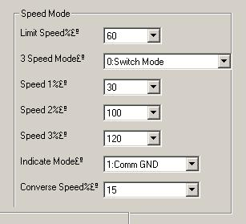
Ground switch OFF:
Dial switch does nothing and the Speed 2% setting (100) is the default.
Ground switch ON:
Dial Position 1: (X1 goes to ground) the Speed 1% setting (30) is active (Grandma Mode).
Dial Position 2: (SL goes to ground) the Limit Speed% setting (60) is active (Casual Mode).
Dial Position 3: (X2 goes to ground) the Speed 3% setting (120) is active (Escape Mode w/ WOT Boost).
Dial Position 4: (DX3 goes to ground) the Converse Speed% setting (15) is active (Mello Reverse mode).
· Adjustable LVC Alternative
It is possible to have a safer adjustable LVC when combined with the "ANY VOLTAGE" transistor modification
Step 1) Install Transistor Mod
Step 2) Flash Controller using LVC = 30.5
Step 3) DO NOT Remove R12 (leave it installed)
Step 4) Run a LVC tap wire (R12 jumper) outside of the controller case
The LVC can now be increased WITHOUT OPENING UP THE CONTROLLER CASE
If no jumper across R12 and ground then LVC stays at 30.5V
If jumper across R12 and ground with 4.3k then LVC becomes 39V
If jumper across R12 and ground with 2.0k then LVC becomes 49V
If jumper across R12 and ground with 1.3k then LVC becomes 59V
Or use a 100k Trim POT to jumper across R12 and ground to set an LVC to any value above 30.5V
If the trim POT (or resistor across R12 and ground) is broken or disconnected the LVC reverts back to 30.5V
If the LVC tap wire goes to ground (accidentally) the controller shuts off at all voltages (but is not damaged)
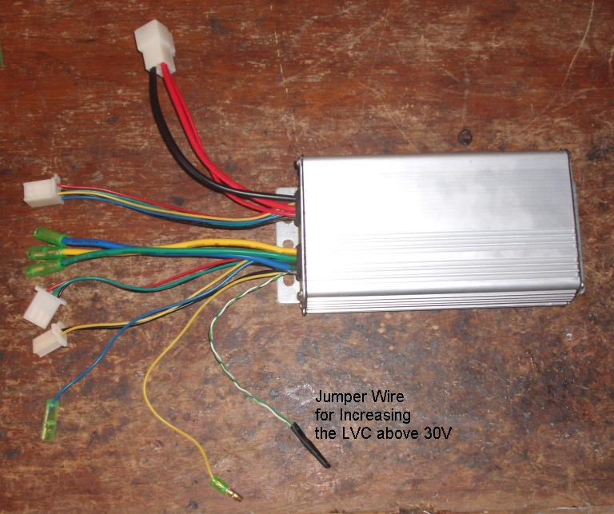

Infineon Controller Custom Modifications
· LVC Potentiometer
The use of a potentiometer to change the LVC is well established.
However, there is a danger involved with this modification.
If the end user sets the LVC POT too low then the current thru the "ignition" electronics
can drop below 65 ma at low battery voltages.
This CAN and WILL cause the MCU and mosfet drivers to malfunction causing the mosfets to short out.
Even when using the "transistor modification" (this mod replaces the standard power resistors),
The LVC is still required to protect the controller (by shutting it off) from a very low voltage condition.
It is very easy for a user to set the LVC too low and blow the controller under a low voltage condition.
I am reluctant to provide this specific modification for this very reason.
If used properly, however, it can still be extremely useful.
The LVC potentiometer is installed by first disabling the R12 resistor from ground.
A small hole can be drilled thru the board that will cut the ground connection.
Then two wires are soldered to the board and a 5K potentiometer is attached to these wires.
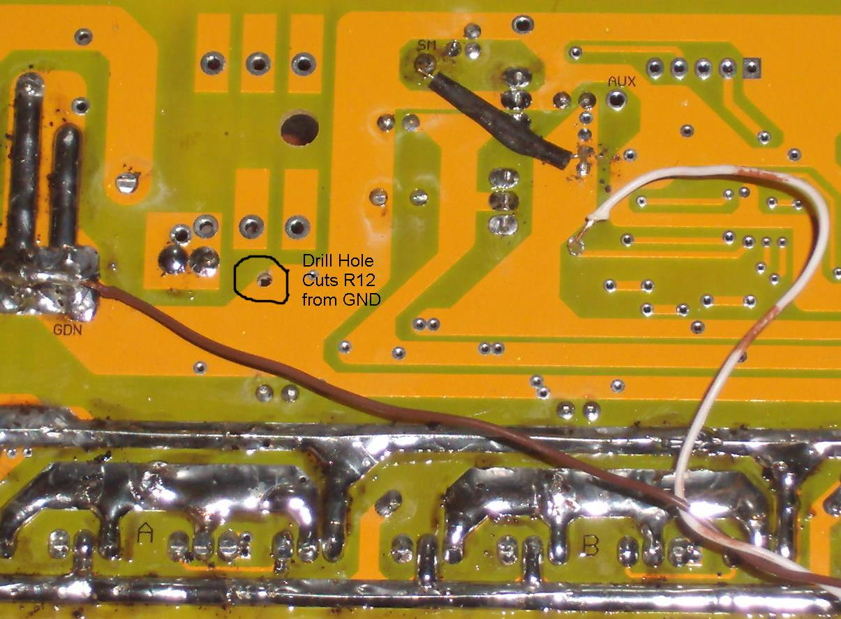

· Power Transistor Modification
As previously indicated the Infineon controller uses power resistors to drop the voltage down to a safe value
for the LM317 voltage regulator. One of these power resistors can be replaced by a transistor.
Unlike a resistor, a transistor will pass the required 65 ma of current over a wide range of voltages.
A transistor's output voltage is controlled by an appropriate zenor diode.
The output voltage will be constant and slightly lower than the zener value even when
the input voltage is far greater than the zener value. If the input voltage is lower
than the zener value the output of the transistor (at 65 ma) is about a constant 3V drop from the input.
A resistor is used to control the current thru the transistor.
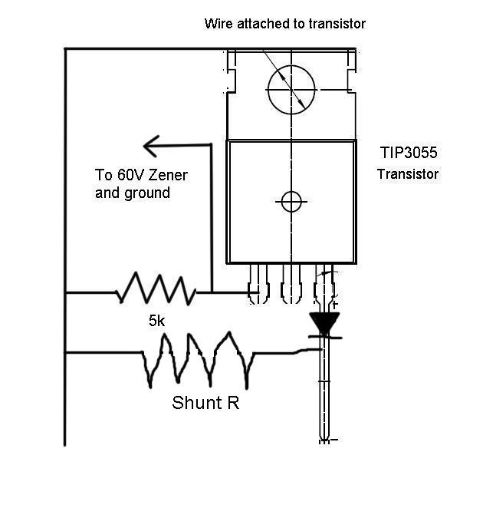
The simple schematic of the transistor circuit (above).
The transistor and 10k resistor before soldering (below).
(I have since decided a 4.7k resistor is even better but 10k still works.)
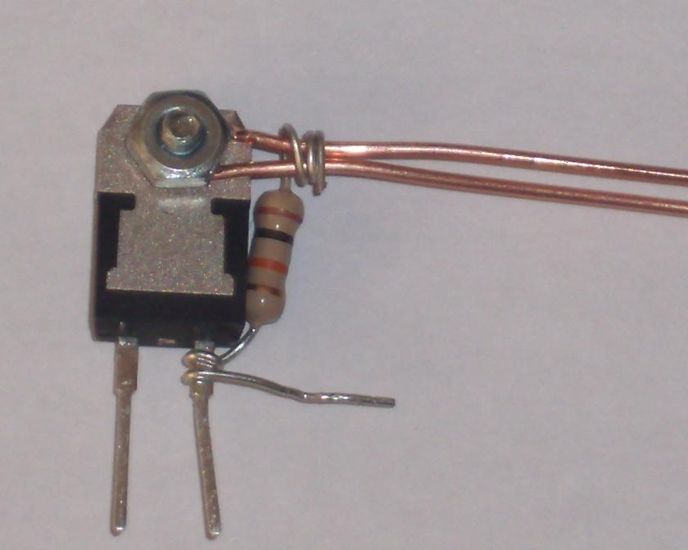
The zener diode is installed from the under side of the pcb.
It is wired to the transitor circuit thru a small hole near the power resistors.
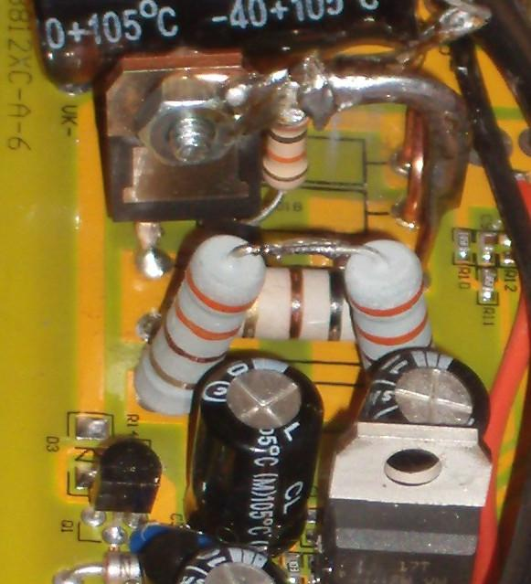
I typically will use a TIP3055 NPN transistor to create the "ANY VOLTAGE" Infineon Controller.
Nominal Battery Voltage = 36V to 72V
LVC = 30 volts
R01A = Transistor (60V zener)
R01B = 200 ohm (2W)
Maximum Safe Operating Voltage = 84 volts

Step by step for Transistor modification:
1) Remove the three power resistors.
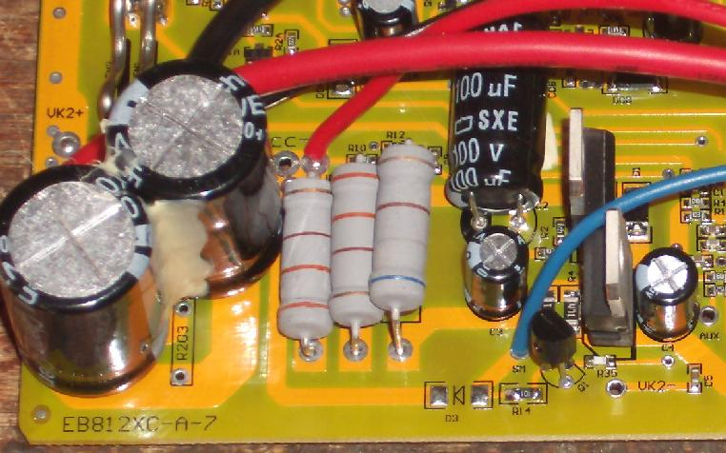
2) Clean out the holes.
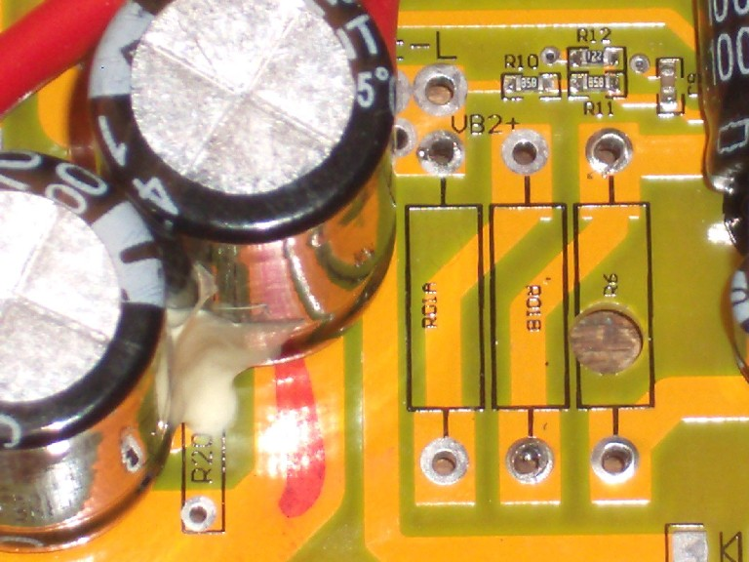

3) Install 680 ohm (3W) in R6 low to the board.

4) Drill a pilot hole in the center of the trace between R01A and R01B.
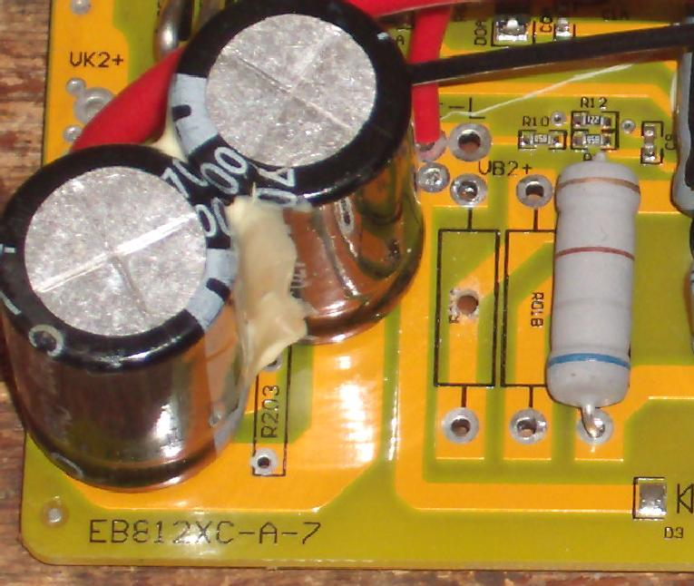

5) Drill a larger hole. This will cut the trace between R01A and R01B and allow room for the Transistor circuit zener.
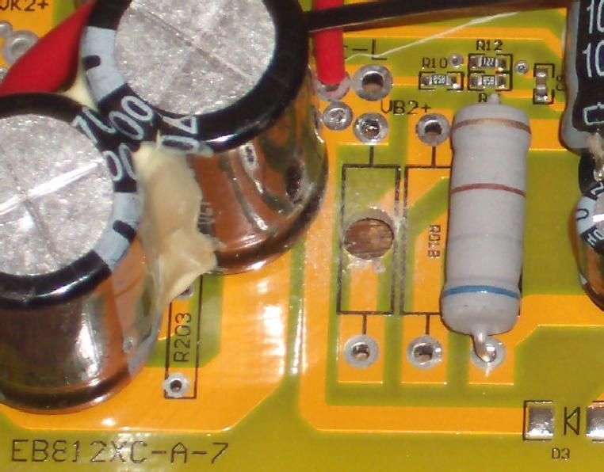

6) Assemble the Transistor circuit.
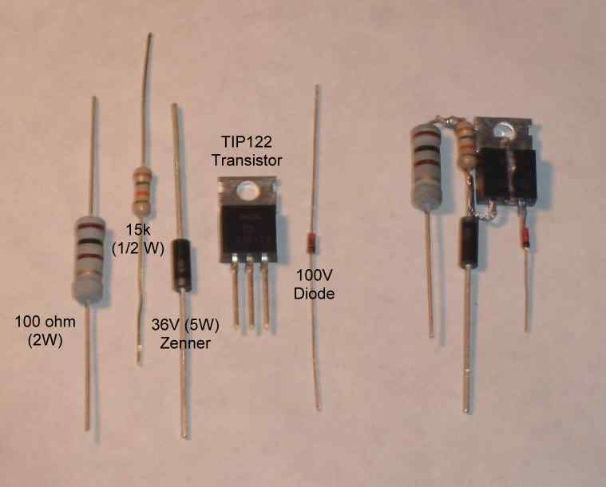
Assemble_Transistor_Circuit.jpg (17.74 KB) Viewed 438 times
NOTE:
The 100 ohm resistor will limit the initial current spike when the "ignition" is first turned on.
The 15k resistor can be substituted with any resistor 10k to 20k.
The 36V zener can be less than 5W (the current thru the 36V zener is very small).
The TIP122 is rated for 100V and has 1000x amplification.
The diode is a safety feature to prevent any reverse current thru the transistor.
7) Install the Transistor circuit in R01A. Install another 680 ohm in R01B.
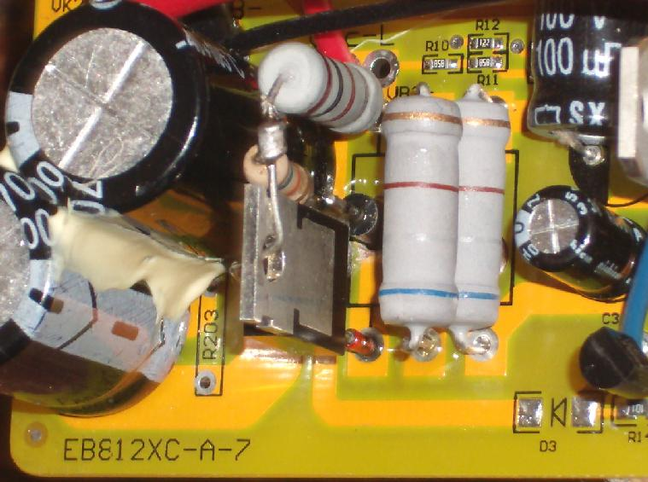

8) Use solder bridges between the V(in) and V(out) of R01A and R01B.
Now the transistor circuit (R01A) is in parallel to the 680 ohm bypass resistor (R01B).
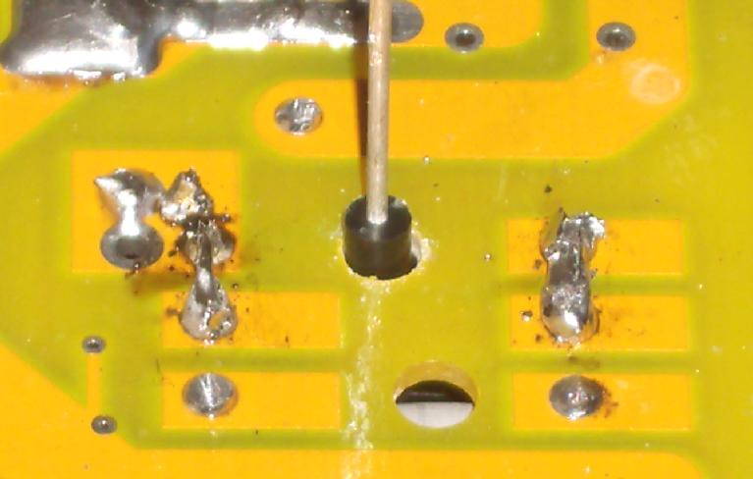

9) Install a 15V(5W) zener between GND and the 12V(15V) bus.
Connect the 36V(5W) zener from the Transistor circuit to the 12V(15V) bus.
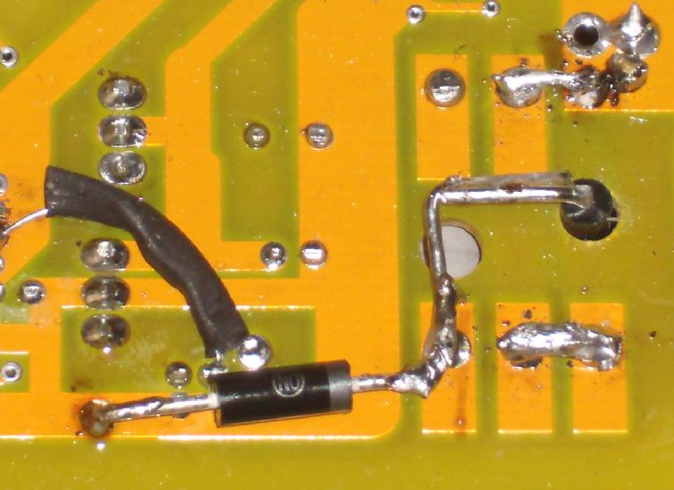
Note:
The 15V zener should be rated at 5W for safety.
This zener will pass significant current (and get warm) if the ignition is connected
to the battery when the peripherals (throttle and motor hall wires) are not connected.
During normal (on-road) operation the 15V zener will not pass any current.
10) OPTIONAL: Now may be a good time to mod R12.
The value of R12 (1200 ohm) affects the LVC AND the Max Regen Voltage.
Adding a resistor in parallel to R12 lowers it's value (in this example R12 becomes 847 ohm).
I like to install (2200+680) 2880 ohm between R12 and GND.
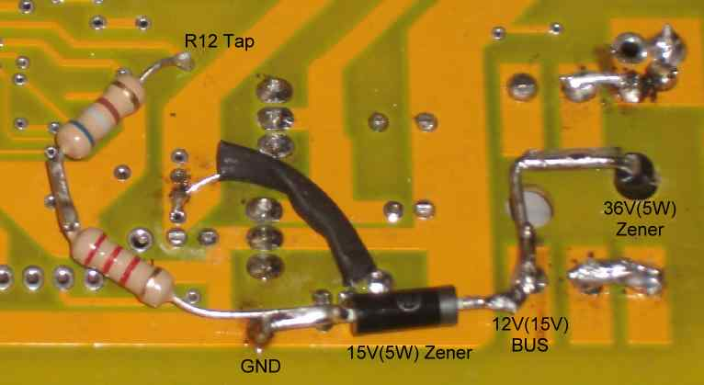

11) OPTIONAL: Jumper BK to GND to activate the Regen feature.
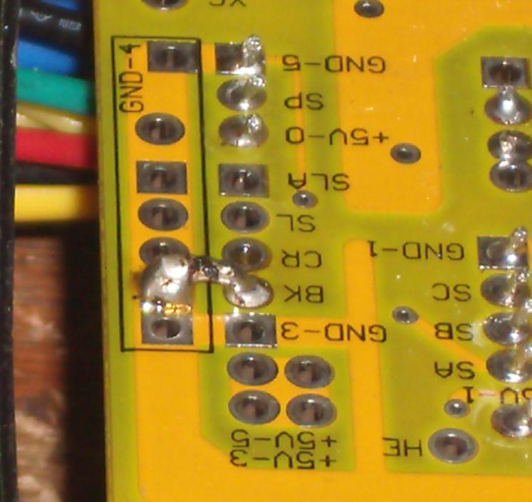

12) SOFTWARE FLASH: Flash the Infineon MCU to desired settings.

Programming connection requires:
Usb ttl connector and cable

The LVC now becomes 20.1 x (1200/847) = 29V
The Max regen now becomes 60 x (1200/847) = 85V
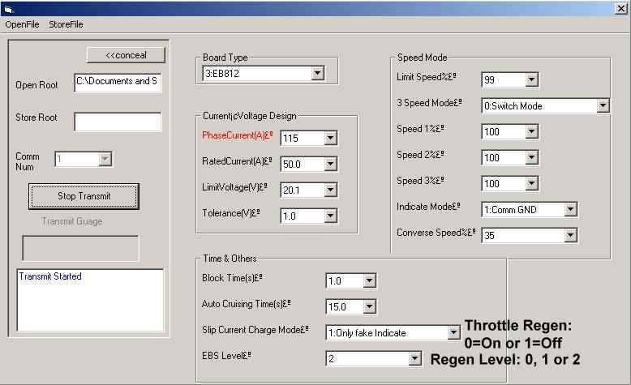
Now the controller will safely accept any battery voltage between 29V and 85V.
It will also regenerative brake and charge the battery between 29V and 85V.

Regen Braking:

The Infineon has Regenerative Braking built into the software programming.
Turns out it was there all along. I could never get it to work, however, because I run at 72V.
Well I hacked that limit. The Infineon is programmed to limit regen voltage to a max of about 60 volts.
So for a 48V battery system (that will accept a reverse current) the regen was there all along.
I am able to increase the MAX regen limit up to about 85V.
I do this by "tricking" the MCU by altering the R12 LVC resistor.
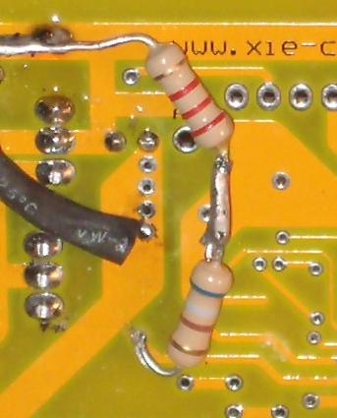
Regen Braking can be programmed to work with the eBrakes and the throttle.
It is activated by jumpering connections on the Infineon pcb.
Jumping (or connecting a switch) from BK to GND activates the Regen braking feature.
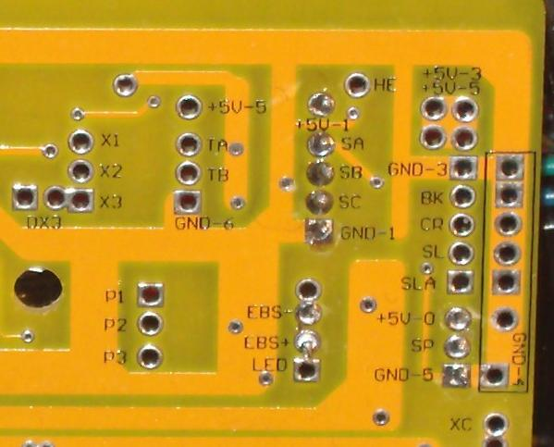
So for now ... I can re-program the Infineon to have an LVC= 29V with a max regen voltage of just under 90 volts.
At the max programmable regen value it really slows the bike down (to a dead stop).
All the energy goes back to the battery. I can basically "brake by wire". Very cool.
Other available programmable features on the Infineon are ...
LVC Settings
Max Current
Cruise Control
Multi Speed Function
Reverse

The degree of regen is software set using the PC flash cable.
There are 3 settings ... EBS Level: 0, 1, and 2 (low medium and high).
I set the level to "2" by default (perfect setting for a 26" wheel).
Lower values (0 or 1) may be better for smaller diameter wheels.
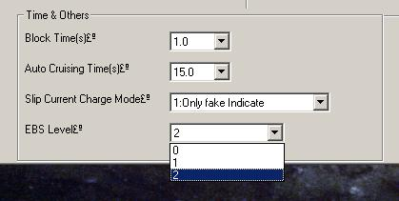
EBS_Level.jpg (13.98 KB) Viewed 817 times
When the eBrakes are applied the Direct Drive hub motor will slow down to a complete stop.
(Max regen voltage is capped at 60V but can be increased to higher values by altering the R12 resistor value.)
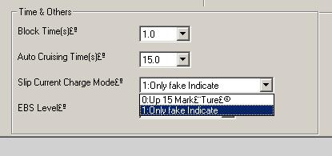
Slip_Current_Charge_Mode.jpg (13.03 KB) Viewed 815 times
The Slip Current Charge Mode feature is either "ON or OFF" and allows regen from the throttle.
Throttling back when cruising will regen the Direct Drive hub motor and slow it down to about 15% of full speed.
The eBrake regen and the Throttle regen act independent of each other.
I set the Throttle regen to "OFF" by default (I like to coast freely when throttled back).
It is just a matter of personal preference.
Jumping the "BK to GND" activates the regen feature.
This can be done with an external switch or be made permanent with a soldered jumper.
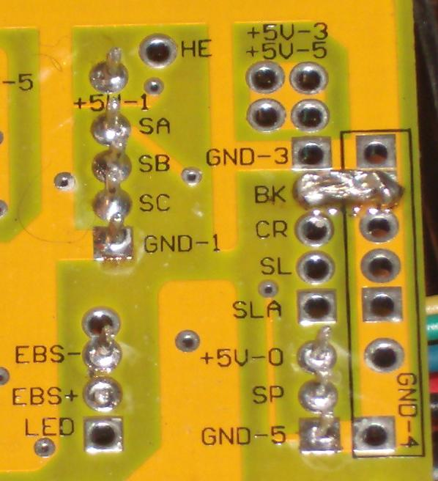
Important: Regen Braking ONLY works if the battery can accept a reverse current.

Neither the throttle regen or the hand eBrake will be active unless the BK to GND circuit is closed.
Once the BK to GND is closed regen will occur whenever the eBrake is slightly closed.
I also rigged up a push button to activate regen without touching the brake levers.
The throttle regen is disabled by setting the "Only fake Indicate" (i.e. throttle regen OFF)
I have not measured the regen current but the braking effect is significant and the battery voltage goes up above nominal.
A Cycle Analyst would do the trick of measuring the regen current.
The faster you are going the more the regen braking effect.
Also (I suspect) lower battery voltages like 48V will regen more pronouncedly than higher voltages like 72V.

There are really only two meaningful pcb hardware mods for the Infineon IMO.
1) Alter the power resistor circuit to allow "Any Voltage" (aka Transistor Mod)
and
2) Alter the R12 MCU circuit to alter the LVC and the maximum regenerative braking voltage.
All other controller functions can be addressed in the Infineon software.
The "Transistor Mod" is a subject in and of it self and I'll leave that to another thread.
The R12 "tweak" is pretty easy to explain so I'll describe that here.
R12 Circuit
A pin out on the MCU connects to the surface mount R12 resistor and then to ground. The stock Infineon R12 value is 1200 ohm. The MCU pin out is fed a tiny amount of current from other resistors on the controller board but the value of R12 dominates the actual pin out voltage for any given battery voltage. With R12 at 1200 ohm, the MCU pin out will vary between about 1 to 6 volts depending on varying battery voltages (20V to 90V) as provided from the thin red (or thin orange) controller battery (+) “ignition” wire.
The MCU reads the R12 voltage as a way to “know” the battery voltage at any point in time. The MCU is programmed with the assumption that R12 = 1200 ohm. Altering the R12 value will “trick” the MCU. This is the basis of the original variable LVC potentiometer that was used BEFORE I got my hands on the software interface.
The controller MCU “sets” the LVC based on the R12 pin out voltage.
BUT …
The MCU (apparently) CAPS the maximum regen braking voltage based on the R12 voltage also. It appears that the Infineon was “hard” programmed with a maximum regen braking voltage of about 60 volts. The max regen voltage value is apparently fixed at 60V and cannot be changed with the software interface (it would be nice if the max regen voltage changed when the software LVC is changed ... but this does not seem to happen).
But changing the R12 value is very easy to do. Adding another resistor from the underside of the board can lower R12. R12 can also be disabled (by drilling a small hole) and replaced with an all-new resistor value or a potentiometer (also from the underside of the board). More details about the R12 circuit are found here ...
viewtopic.php?f=16&t=7361#p110932
Changing R12 will change BOTH the LVC AND THE MAX REGEN braking voltage.
Lowering the R12 resistor value below 1200 ohm INCREASES the "real" LVC.
(and also increases the max braking voltage above 60V)
Increasing the R12 resistor value above 1200 ohm DECREASES the "real" LVC.
(and also decreases the max braking voltage below 60V)
EXAMPLE
Install a 2880 ohm in parallel to R12. R12(new) now equals 847 ohm.
1/R12(new) = (1/1200) + (1/2880), R12(new) =847
Now if you program the LVC to say 20.1 volts, the “real” LVC becomes 28.5 Volts
(20.1v) x (1200) / (847) = 28.5v
AND
The “real” max regen voltage becomes 85 Volts
(60v) x (1200) / (847) = 85 Volts

Power board altnerate power source:
The LVC is measured from the ignition circuit (+) not the mosfet power circuit (+).
If the "logic supply" was to "dive" the LVC would turn the controller off and no damage would occur.
The LVC WILL NOT protect the main battery. The LVC measures the voltage of the "logic supply" NOT the MAIN BATTERY.
Example: Use software to set LVC=20.1V. Use 3 x 9V batteries (27V) to power the thin red "ignition" wire.
The controller will now run ANY MAIN BATTERY power 0 - 90 volts (up to the limit of the caps and fets of course - assumed to be 100V).
Once the 3 x 9V batteries drop below 20.1 V the controller shuts off. Does not matter what the MAIN BATTERY voltage is at all.
These are two completely independent circuits. They only share a common ground.
HOWEVER ... A 9V battery may be only 200 mAH. At 60 ma needed then at best you get 3 hours of "ON" time before they need to be changed.

